District 28 GSR Meeting, 6/29/25

Attendance
Present? | GROUP NAME | NAME | ROLE | EMAIL
 | Addictive Personalities | Tre W. | GSR | williamstre342@gmail.com
yes | Avalon | Geoff G. | GSR | geoffmgailey@gmail.com
 | Becoming Teachable Group | Bella A. | GSR | pianogirl2628@yahoo.com
 | Becoming Teachable Group | Darlene L. | GSR | darlenec.ce@gmail.com
yes | Becoming Teachable Group | Mark F. | DCM | mark.ferrell403@gmail.com
yes | Carrying the Message Men's | Nick L. | GSR/Secretary | gnicklarkin@gmail.com
 | Castleton Beginners Big Book Study | James M. | GSR | jimbobarewski7@gmail.com
 | Circle City Friends | Jennah B. | GSR | jennahbiswas1@gmail.com
yes | Fort Harrison Group | Brian M. | GSR | bdmyers.art@gmail.com
yes | Hope On Friday | Sonnet H. | District Treasurer | sonnetharris@gmail.com
 | Meyerson Group | Tommy S. | GSR | tommysmithes1980@gmail.com
 | Myerson Group | Andrew E. |  | andrewedgington1111@hotmail.com
 | Saturday Morning Live | Darryl S. | GSR | 2883.rex@gmail.com
 | Saturday Night Gay-Le Group | Teresa H. | GSR | teresahultz6@gmail.com
 | Sunday Night Gay Group | Isaac K. |  | isaackantor@gmail.com
 | T.G.I.F. Group | Earl R. | GSR | earlrice517@gmail.com

Call to Order
The regular meeting for District 28 GSRs was called to order at 10:30am by Mark F., DCM.

Treasure’s Report
Treasurer was absent from the meeting. This is a screen shot of the report provided via email to District 28 GSRs/DCM on 6/28/25:
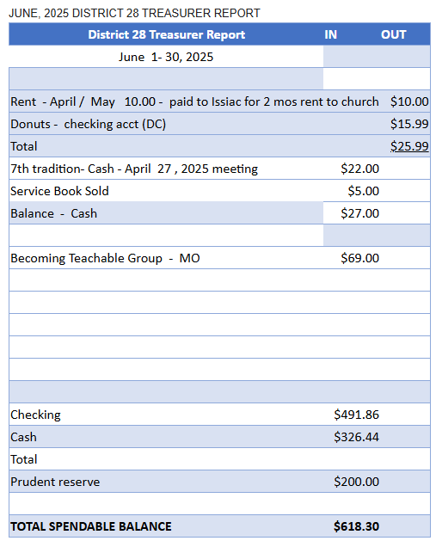
Approved: 5
Opposed: 0

Secretary’s Report
Last month Isaac K. served as interim Secretary but was absent from today’s meeting. There is no report to approve.
(note: Nick L. is now serving as District 28 Secretary).

Other Topics
East Central Regional Forum Discussion
- The forum includes Areas from Indiana, Kentucky, Michigan, Wisconsin, Ohio, and Illinois.
- Hosted in Indy at the Marriot August 22-24
- Links to volunteer opportunities and other details on the District website.
Tradition Six Discussion
- The 6th Tradition emphasizes the importance AA meetings being self-support and avoiding financial entanglements.
- Discussed the potential risks of celebrity endorsements of AA and the importance of maintaining AA's integrity.
Birthday Celebrations and Fellowship
- Congratulations to Bella for 2 years!

