District 28 DCM/GSR Meeting, 7/26/26

Attendance
Present | Group Name | Name | Role | Email
 | Addictive Personalities | Tre W. | GSR | williamstre342@gmail.com
 | Avalon Group | Matt S. | GSR | msliepka87@gmail.com
 | Becoming Teachable Group | Anthony W. | GSR | whitesideanthony33@gmail.com
yes | Carrying the Message Men's | Nick L. | GSR/ Secretary | gnicklarkin@gmail.com
 | Carrying the Message Men's | Mike F. | Alt GSR | michaeljfinnigan@gmail.com
 | Castleton Beginners Big Book Study | James M. | GSR | jimbobarewski7@gmail.com
 | Circle City Friends | Jennah B. | Alt GSR | jennahbiswas1@gmail.com
yes | Fort Harrison Group | Brian M. | Treasurer | bdmyers.art@gmail.com
yes | Fort Harrison Group | Jerry O. | GSR | Emmy31a@yahoo.com
 | Meyerson Group | Tommy S. | GSR | tommysmithes1980@gmail.com
 | Meyerson Group | Andrew E. | GSR | andrewedgington1111@hotmail.com
 | Saturday Morning Live | Darryl S. | GSR | 2883.rex@gmail.com
yes | Saturday Night Gay-Le Group | Jim C. | GSR | Jpconnell58@outlook.com
yes | Saturday Night Gay-Le Group | Teresa H. | DCM | district28@area23aa.org  (please use for DCM comms)
 | T.G.I.F. Group | Matt R. | GSR | livinitupinMavi@gmail.com

Call to Order
The regular meeting for District 28 DCM and GSRs was called to order at 10:30am by Teresa H., DCM.

Approved: 5
Opposed: 0

Treasurer’s Report
Brian and Nick met with a bank manager at Chase Bank on Monument Circle on 7/24/26. All names were removed from the District 28 bank account except Brian’s name. Teresa and Brian will coordinate to have her name added as well.

District 28 Bank Account, current balances
Checking $1,415.98
Prudent reserve $200
Cash $142
Total spendable balance $1,357.98
Notes:
- $5 rent paid on 6/28/2026
- Paypal and Venmo contributions included in balance; need to be quantified

Other Treasurer updates
- Replacement debit card and checks are pending
- Personal checks and money orders listed in 6/27/2026 Treasurer report will be deposited and receipts will be issued.

2026 District 28 Home Group Contributions (to date)
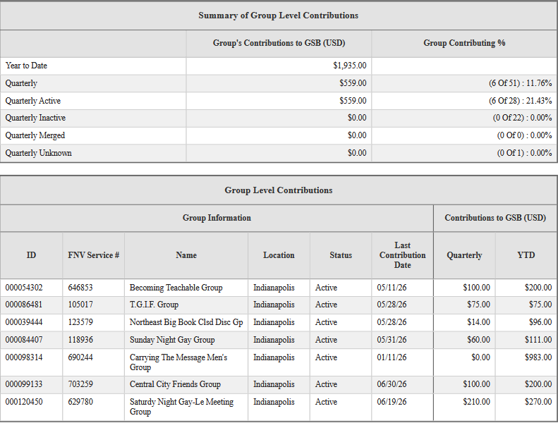

Approved: 5
Opposed: 0

Secretary’s Report
- Reviewed previous meeting minutes
- Noted lessons learned:
  - It is crucial for the Secretary to clearly document service position elections in meeting minutes, as these might be used by external organizations (e.g. the bank with our District 28 account)
  - It actually is important to upload monthly meeting minutes to the District 28 website for future service position holders
- Distributed copies of the Corrections Workshop flyer

Approved: 5
Opposed: 0

DCM’s Report
- Correction Workshop, Saturday 8/29/26, 2-4pm at Club East
  - Co-hosted by Districts 28 & 30
  - District 28 will provide snacks
  - Anthony W. and Janet E. will be contributing baked goods
  - Teresa will contribute packaged snacks
  - We have access to the room from 1-5pm
  - Please arrive between 1 and 2pm to support set up

- Area 23 Area Assembly (fall)
  - When: August 16, 2026, 9am – 3:30pm
  - Where: Northside Social Club, 2100 E 71st St, Indianapolis, IN 46220
  - Co-hosted by Districts 24 & 26
  - In person attendance encouraged; Zoom option (Zoom Link)
    - Meeting ID: 542 300 4095
    - Passcode: area23

- Area 23 2026 General Service Weekend and Area Assembly (winter)
  - https://area23aa.org/event/area-23-service-weekend-2026
  - Click here for the flyer
  - When: November 13, 2026 @ 4pm – November 14, 2026 @ 4pm
  - Where: Abe Martin Lodge, 1405 IN-46 W., Nashville, IN 47448
  - Reservations: 812-988-4418
    - Mention Group Code 1113AR for the group discount before 10/12/26

- Annual International Conference of Young People
  - When: Labor Day weekend (Sept 3-6)
  - Where: Grand Rapids, MI
  - Check out the website to register ($55) and for room reservations.
  - https://www.icypaa.org/

- Shared Google Drive for District 28 DCM and GSRs: HERE
  - Flyers
  - Service work documents

Approved: 5
Opposed: 0

Area 23 Delegate visit
Todd K. (delegate@area23aa.org) visited District 28’s July monthly meeting
- Discussed the 76th General Service Conference agenda item and results
- Todd explained the evolving financial landscape
- Suggests we consider digital Grapevine subscriptions via Grapevine App
- Requests we promote the Grapevine Podcast in our Home Groups
- Recommends Grapevine content
  - on Youtube (@AAGrapevine)
  - on Instagram (@alcoholicsanonymous_gv)

Other Topics
Tradition 7 of Alcoholics Anonymous
“Every A.A. group ought to be fully self-supporting, declining outside contributions.”

Where Money and Spirituality Mix pamphlet

Next Monthly District 28 DCM/GSR Meeting:
Roberts Park Church, Sunday, 8/30/26, at 10:30am

