District 28 GSR Meeting, 9/28/25

Attendance
Present? | GROUP NAME | NAME | ROLE | EMAIL
 | Addictive Personalities | Tre W. | GSR | williamstre342@gmail.com
 | Avalon | Geoff G. | GSR | geoffmgailey@gmail.com
yes | Becoming Teachable Group | Bella A. | GSR | pianogirl2628@yahoo.com
 | Becoming Teachable Group | Darlene L. | GSR | darlenec.ce@gmail.com
yes | Becoming Teachable Group | Mark F. | DCM | mark.ferrell403@gmail.com
yes | Carrying the Message Men's | Nick L. | GSR/Secretary | gnicklarkin@gmail.com
 | Castleton Beginners Big Book Study | James M. | GSR | jimbobarewski7@gmail.com
 | Circle City Friends |  | GSR
 | Fort Harrison Group | Brian M. | GSR | bdmyers.art@gmail.com
yes | Hope On Friday | Sonnet H. | District Treasurer | sonnetharris@gmail.com
 | Meyerson Group | Tommy S. | GSR | tommysmithes1980@gmail.com
 | Myerson Group | Andrew E. |  | andrewedgington1111@hotmail.com
 | Saturday Morning Live | Darryl S. | GSR | 2883.rex@gmail.com
yes | Saturday Night Gay-Le Group | Teresa H. | GSR | teresahultz6@gmail.com
 | Sunday Night Gay Group | Isaac K. |  | isaackantor@gmail.com
 | T.G.I.F. Group | Earl R. | GSR | earlrice517@gmail.com

Call to Order
The regular meeting for District 28 GSRs was called to order at 10:30am by Mark F., DCM.

Treasure’s Report
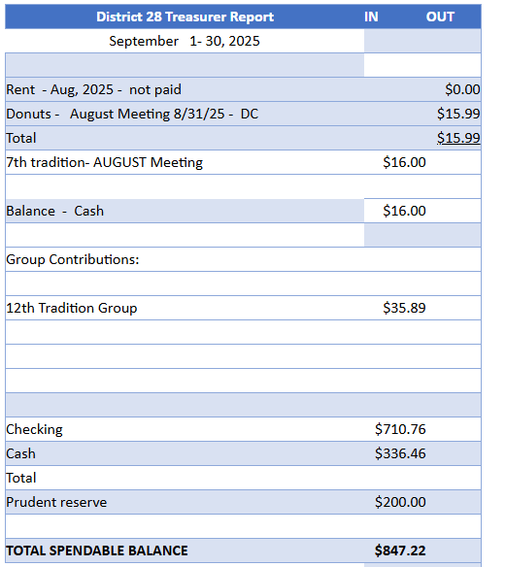
Approved: 5
Opposed: 0

Secretary’s Report (from week prior)
Last month’s Secretary’s Report was approved.

Approved: 5
Opposed: 0

DCM’s Report
Nick will investigate whether Fairbanks is available for District 28 to host the next Area Assembly in 2026. Requirements would be space and facilities for up to 125 people, as well as Wi-Fi access and preferably a sound system.
Our district is still in need of a new Treasurer and Alternate Treasurer, as well as an Alternate Secretary (Nick will continue to serve as Secretary for District 28).
Reminder that as GSR for your home group, you are tasked with chairing your home group’s business meetings.

Approved: 5
Opposed: 0

Other Topics
New DCM and Alternate DCM
New Teresa was elected the new DCM and Sonnet was elected the new Alternate DCM, starting in December 2025.
Approved: 5
Opposed: 0
2025 Area 23 Inventory
2025 Area 23 Inventory
All GSRs are asked to complete the 2025 Area 23 Inventory:
https://docs.google.com/forms/d/e/1FAIpQLSdYg3HfkygzgZUVpFwH1pwKTbhWTn4zGo15NhQIemGPwlNmsg/viewform
Area 23 Service Weekend
All GSRs are encouraged to participate in the Area 23 Service Weekend, November 14-16, in Nashville, Indiana. The base cost is $60 with the following optional expenses:
- $35 for Saturday Dinner
- $9.50 for Saturday Ice Cream Social
- $20 for Sunday Lunch.
Assembly-only attendees can register for Sunday lunch, $20 per person.
Registration is available online:
https://area23aa.org/event/2025-service-weekend#onlineregister
Next meeting
At 10:30am on Sunday, 10/26/25, at Roberts Park United Methodist Church
Birthday Celebrations and Fellowship
- We all have today!

